Birding Trip report


Central Peru
including Santa Eulalia, Oxapampa, Villa Rica
and Satipo road
November 3rd to 12th 2007
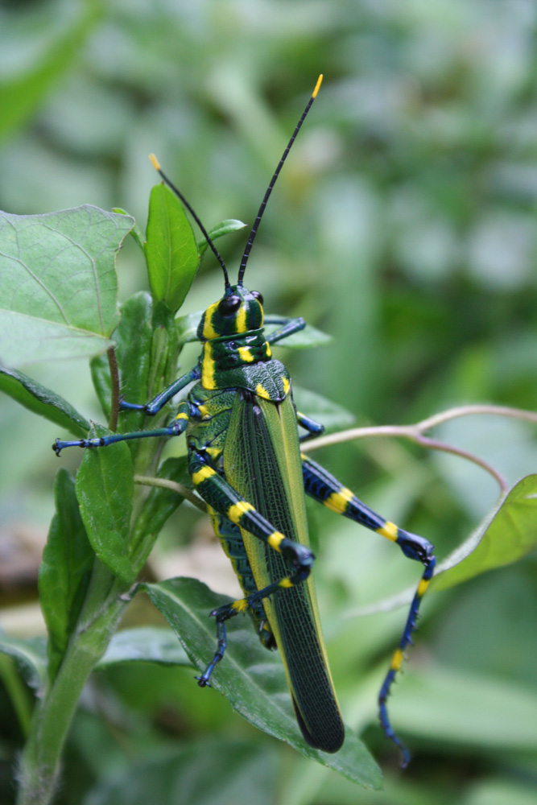
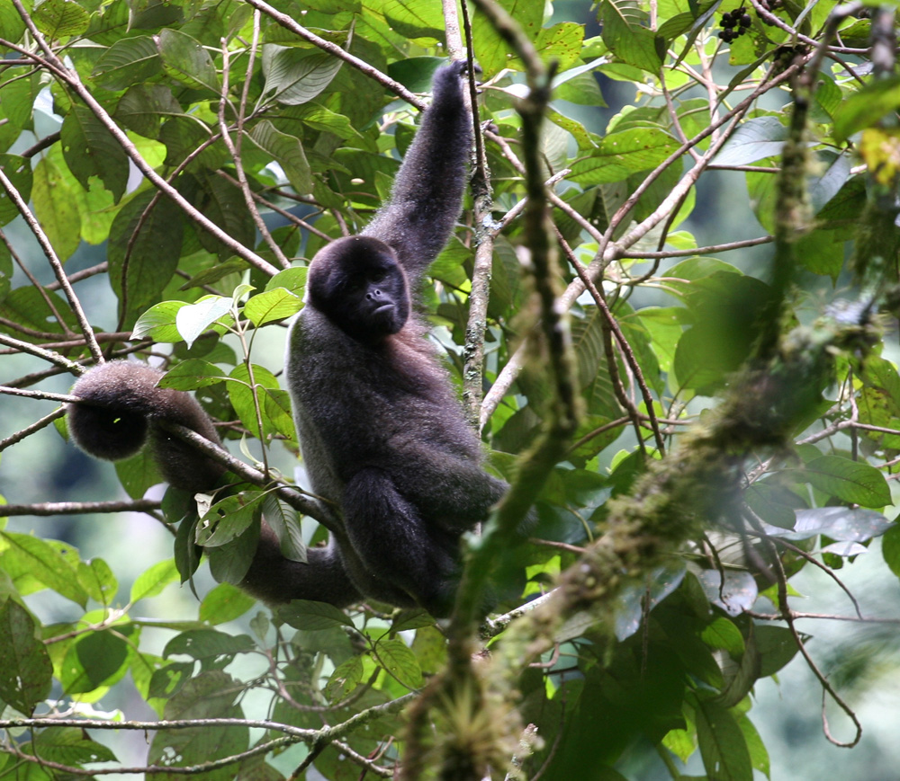
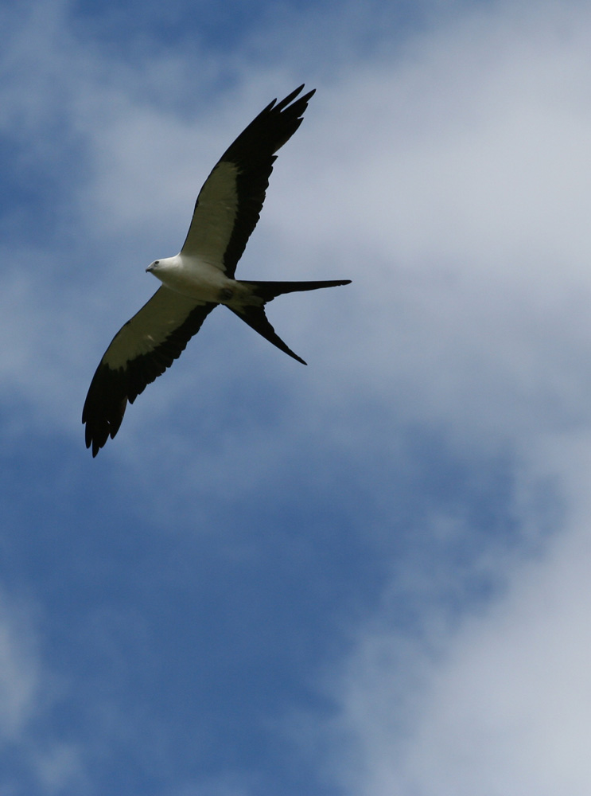

Leader, report redaction : Fabrice Schmitt
Participants : Elisabeth Hassler and Renate Kalz
Driver/cook : Julio Benites

In November 2007, I guided a birding trip for the German Ornitravel company http://www.ornitravel.com/. Logistics were done by Kolibri Expeditions www.kolibriexpeditions.com

The main part of the trip was 10 days in the central Peru, known to be one of the best place to find restricted range species. We visited the dry Santa Eulalia valley, the coffee plantations around Villa Rica, the Cloud Forest of Oxapampa, the famous Satipo road (cloud and elfin forest) and the fantastic dry valley around Comas surrounded by puna grassland.

Many wonderful birds are present is this seldom birded area: Black-and-chestnut Eagle, Diademed Sandpiper-plover, Cloud-forest Screech-owl, Fire-throated Metaltail, Creamy-bellied Antwren, Red-billed and Peruvian Tyrannulet, Scarlet-bellied, Yellow-scarfed and Blue-browed Tanager, Rufous-breasted Warbling-finch, and so many more...

Two very interesting sightings have been done during this trip:
First of all, the discovery of a singing male of Black-billed Seed-finch (Oryzoborus atrirostri) on the way to Villa Rica. According to the wonderful Schulenberg et al. book of Birds of Peru, this would be the first record for the Junin department.
Unfortunately, I don't have any proof (picture, sound recording) to document this record.
This bird was found in a small marsh few kilometers after the turn-off from the main paved road San Ramon-Satipo, about 500 meters after a botanical garden (10°56'53''S - 75°17'20W - 670 m according to Google Earth). This marsh is very interesting and many good birds can be seen here. I would be interested to know if other birder find the Seed-finch again.

The second interesting sighting, much more exciting, was the discovery of a undescribed mammal, belonging to the Monodelphis genus (Short-tailed Opossum).
We found this small mammal above Villa Rica in cloud forest.
In fact, this animal was already discovered by Peruvian mammalogist (that we didn't know when we found it!!) and will be formally described soon.
Peru is one of these few countries where you can find an undescribed species during your holidays!! So exciting!

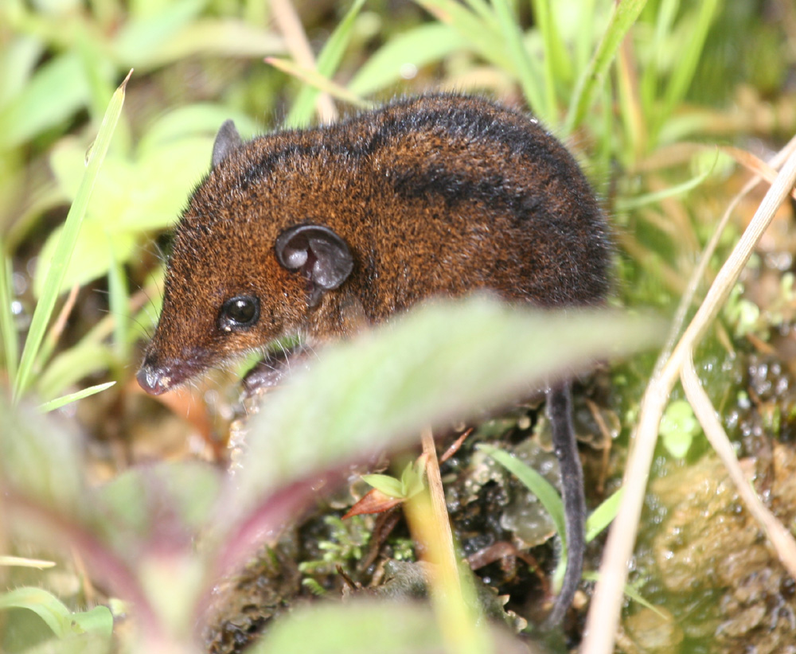
A new species of Monodelphis found near Villa Rica!

Itinerary

November 3rd
We left the Melodía Hotel at 4:30 am to the Santa Eulalia valley. For our first stop, Elisabeth quickly found a Great Inca-finch. A wonderful view on this first Peruvian endemic of the trip!!
We also found there few groups of Mountain Parakeet, Bare-faced Ground-dove, 2 Black-chested Buzzard-eagle and several Purple-collared Woodstar.
During our second stop, we added a pair of Peruvian Pygmy-owl, 1 Black-necked Woodpecker, 1 Andean Tinamou and few Golden-bellied Grosbeaks.
We then drove to the Huachupampa area where we found very easily 2 Rufous-breasted Warbling-finch, 1 Bronze-tailed Comet, few Rusty-bellied Brush-finch, and 1 Giant Hummingbird.
At 8:30 am, we already saw most of the specialties of the lower Santa Eulalia valley!! We merited a nice breakfast with a wonderful landscape and 3 Andean Condors flying overhead!
During the rest of the day, we slowly drove back to Lima, adding always more species to our list, as Black Metaltail, Canyon Canastero, Pied-crested Tit-tyrant or Collared Warbling-finch.
In Lima we stopped one hour in a nice hotel for an appreciated shower, and after dinner, we took a public bus for a night drive to San Ramon.

November 4th
Our driver, Julio Benites, is waiting us at 6:30 am in San Ramon. We directly drove to the Villa Rica/Oxapampa cross-road where we had our breakfast, close to a botanical garden where we saw our first Bluish-fronted Jacamar, White-eyed Parakeet, and Blue-headed Parrot. We also heard a Tataupa Tinamou without finding it.
This first morning was amazing; all the birds we found belong to another species!! Barred Antshrike, Chestnut-bellied Seedeater, Yellow-browed Sparrow, Little Woodpecker, Chestnut-eared Aracari, Long-tailed Tyrant, Plumbeous Kite, Magpie Tanager, Common Tody-flycatcher, and many many more!!
We even found the rare and localized Black-billed Seed-finch, a new species for the Junin department!
We stopped for lunch in a coffee plantation where the activity was absolutely incredible! One of the first bird we found was a Creamy-bellied Antwren (endemic to Peru), in a flowering tree full of Sparkling Violet-ear and White-bellied Hummingbird!
On our way to Oxapampa, we also added some wonderful birds as Swallow-tailed Kite or Blue-banded Toucanet.
We arrived in our very nice hotel in Oxapampa at 5 pm.

November 5th
We left the hotel at 4:00 am to drive directly to the Antenna road, where we tried the Cloud-forest Screech-owl. Unfortunately, he didn’t play the game and we dipped on this rare endemic.
Anyway, we found some other interesting species as Striated Treehunter, Long-tailed Antbird, Collared Inca and we even had a great view on a White-crowned Tapaculo.
After our breakfast in this wonderful pristine forest, we walk down a part of the antenna road, where we found many orchid species (Renate is an orchid specialist!!) and few birds as Yellow-scarfed Tanager, Amethyst-throated Sunangel, Tricolored and Slaty Brush-finch.
After picking up Elisabeth who stayed at the hotel this morning, we drove to Pozuzo via the Yanachaga-Chemillen NP.
Again, many nice species on the way, as Blue-headed Macaw, Gilded Barbet, Mottle-backed Elaenia, Lemon-browed Flycatcher or Speckled Chachalaca.
We arrived in the late evening in our comfortable hotel in Pozuzo, owned by a descendant of Austrian immigrants.

November 6th
Again, an early morning in the field. We drove on a very bad and wet road to reach a Cock-of-the-Rock lek. We saw there around 15 males displaying, but unfortunately the weather was bad and the rain obliged us to leave the place…
This lek is in the yard of an Austrian-Peruvian family. In fact, the Pozuzo and Oxapampa area is known for his Austrian-german community arrived in Peru around 1850. The people belonging to this community still speak the Tyrolian dialect… as do Elisabeth and Renate!! It was just incredible for them to travel thousands of kilometers, to arrive in tropical forest and speak the same dialect than at home!!
After a nice breakfast surrounded by birds in the garden of our hotel, we drove back to Oxapampa. On the way, we saw a wonderful Solitary Eagle carrying a snake, Blue-crowned Motmot and so many Roadside Hawks. We also saw our first monkeys: two groups of Brown Capuchin Monkey, and a nice group of Whooly Monkey who stayed close to us during our lunch.

November 7th
We left the hotel at 3:30 am for a second try for the Cloud-forest Screech-owl. Unfortunately, as soon as we arrived close to the antenna, we had rain that obliged us to stay in the minibus for two hours. We drove back to Pozuzo where we stayed all the morning, waiting the rain stop.
The weather changed in the end of the morning, and allowed us to bird a little bit on the way to Villa Rica. Rufous-capped Thornbill, Golden-olive Woodpecker, Hook-billed Kite, Long-tailed Sylph and Peruvian Tyrannulet were some of the best birds, but the bird of the day is definitely a wonderful adult of Black-and-chestnut Eagle landed close to the road!!
This afternoon, we had the incredible surprise to discover a new species of mammals!!
On the border of the road we where birding, we found this small "Shrew-like" mammal while it was looking for food in the vegetation. We took many pictures of this nice "mouse", in fact a short-tailed Opossum, and back home Fabrice discovered it was an undescribed species!! Other individuals have already been found in 3 places of Peru, and the description of this species will be published soon.
In the late evening, we birded the Oconal lagoon where we saw many wetlands species as Least Grebe, Wattled Jacana, Blackish Rail, Cocoi Heron, and Purple Gallinule.

November 8th
We spent all the day around Villa Rica, where we had excellent birding in the coffee plantation. The activity is just amazing, and we never stopped to add new species.
The bests of the birds we found this day were Red-billed Tyrannulet, Chestnut-backed Antshrike, White-winged Tanager, Ocellated Piculet, Lineated Woodpecker, Streaked Xenops, Stripe-chested Antwren and Swallow Tanager.
We also found many boreal migrants as Canada or Blackburnian Warbler, and Swainson Thrush.
At 3 p.m., we again had rain stopping the birding for the end of the day.
After dinner, as rain stopped, we looked for owls and had a wonderful close view on a Band-bellied Owl.

November 9th
Early morning for a couple of hours birding in the coffee plantation close to Villa Rica, and we then drove to Satipo.
On the way we stopped for few nice birds as White-browed Antbird, a small flock of Swallow-tailed Kite close to the minibus, and Blue-crowned Motmot.
The habitat around Satipo is degraded and mostly dedicated to the citrus fruits culture, where we only saw some common and widespread species as Chestnut-bellied and Yellow-bellied Seedeater, Streaked Flycatcher, Silver-beaked Tanager or Black-billed Thrush.

November 10th
We spent all the day below the village of Calabaza where good subtropical forest still exists. Anyway, the activity was fairly low and we found few mixed species flocks.
The good birds of the day where Torrent Duck, White-backed Fire-eye, 1 Amazonian Umbrellabird, 1 Inca Flycatcher, few Golden-crowned Flycatcher, Blue Dacnis and Dusky-green Oropendola. We also had excellent view on 2 Black Spider Monkey.
We also had several views of Black-throated Toucanet, a probable forthcoming split of the Emerald Toucanet.
At the end of our day, we even spotted a Ferrugineous Pygmy-owl in a Cecropia tree.

November 11th
A long day today as we had to drive 250 km on a unpaved road and we had lot’s of birds to see on the way!!
For breakfast, we already had good flocks, including several species of Hemispingus and Tanager (even the rare Blue-browed Tanager!) and a nice view of a full grown chick of Black-and-chestnut Eagle on his nest.
We did a short stop at the Atalaya community; with witch Kolibri Expedition is starting an ecotourism project. Elisabeth and Renate gave some educational materials to the school, very appreciated by the teacher.
Around Carrizales, in the elfin forest, we found the endemics Eye-ringed Thistletail and Fire-eyed Metaltail, the beautiful Scarlet-bellied Mountain-tanager, a Moustached Flowerpiercer and the sapphiropygia subspecies of Sapphire-vented Puffleg that will probably be split as Coppery-naped Puffleg.
After lunch we still have a long way to drive, and so few time to stop for the birds. The landscapes were absolutely amazing and we drove through very typical Andean villages. As we left the cloud forest, we found completely different bird species almost all named as “Andean” : Andean Goose, Andean Flicker, Andean Gull, Andean Ibis, Andean Duck, Andean Lapwing, etc… but also Striated Earthcreeper, Peruvian Sierra-finch, Paramo Seedeater, Puna Hawk, Giant Coot…
Just before to reach Concepcion where we spent the night, we even found a Magellanic Horned Owl!!

November 12th
We have a little bit more time today to have a better look on all the species we saw briefly the day before.
On the Ticlio bog, we found a huge group of 23 Rufous-bellied Seedsnipe, 1 Gray-breasted Seedsnipe, few White-fronted Ground-tyrants, 2 White-fronted Ground-tyrant and of course the specialty of the place: the endemic and endangered White-bellied Cinclodes whose total population is probably less than 500 birds!
On another bog we found a pair of Diademed Plover, one of the most sought-after species in Peru.
Slender-billed Miner, Plain-breasted Earthcreeper, Black Siskin, Junin Canastero, Ash-breasted Sierra-finch and Taczanowski’s Ground-tyrant are some of the other species seen that day.
We arrived at Lima at 5 p.m. for a merited rest.

Bird List

The * indicates a species whose total range is less than 50.000 km²
The species in bold are globally endangered species. The abbreviation in front of the species name indicate the threat level (nt: near-threatened, Vul: Vulnerable, End: Endangered, Crit: Critical)

The German names come from the Avibase WebPages.

TINAMIFORMES: Tinamidae

Brown Tinamou - Crypturellus obsoletus - Kastanientinamu
Heard only in the Yanachaga-Chemillen NP and on the Satipo road

Tataupa Tinamou - Crypturellus tataupa - Tataupatinamu
Heard only, near the Oxapampa junction and near Satipo.

Andean Tinamou - Nothoprocta pentlandii - Andensteißhuhn
1 seen in the Santa Eulalia valley

PODICIPEDIFORMES: Podicipedidae

Least Grebe - Tachybaptus dominicus - Schwarzkopftaucher
At least 50 birds on the Oconal lagoon. Many of them are displaying or incubating.

Silvery Grebe Podiceps occipitalis Inkataucher
1 on a small piece of water, before the Ticlio pass.

PELECANIFORMES: Phalacrocoracidae

Neotropic Cormorant - Phalacrocorax brasilianus - Olivenscharbe
Fairly common in the lowland to 1500 m.

CICONIIFORMES: Ardeidae

Cocoi Heron - Ardea cocoi - Cocoireiher
10-20 birds in the Oconal lagoon.

Great Egret - Ardea alba - Silberreiher
Seen around Lima, in the Oconal lagoon and around Satipo.

Snowy Egret - Egretta thula - Schmuckreiher
2 on the Oconal lagoon

Cattle Egret - Bubulcus ibis - Kuhreiher
2 near Satipo

Striated Heron - Butorides striata - Mangrovereiher
Common on the Oconal lagoon. Also seen around Satipo.

Black-crowned Night-Heron - Nycticorax nycticorax - Nachtreiher
10+ on the Oconal lagoon, and 4 birds before the Ticlio pass at around 4000 m. elevation.

Fasciated Tiger-Heron - Tigrisoma fasciatum - Streifenreiher
Few sightings near Pozuzo and on the way to Satipo.

CICONIIFORMES: Threskiornithidae

Andean Ibis - Theristicus branickii - Schwarzzügelibis
2 birds in the puna, in the highest part of the road between Satipo and Concepcion.

Puna Ibis - Plegadis ridgwayi - Punaibis
10 at the Ticlio pass.

ANSERIFORMES: Anatidae

Andean Goose - Chloephaga melanoptera - Andengans
Fairly common at high elevation

Torrent Duck - Merganetta armata - Sturzbachente
1 male on the way to Pozuzo, and 1 female on the Satipo road.

Speckled Teal - Anas flavirostris - Andenente
10 on a small piece of water before the Ticlio bog. These ones belong to the oxyptera subspecies that will perhaps be split in the future (sometimes called “Yellow-billed Teal”)

Crested Duck - Anas specularioides - Schopfente
Few seen on the way to Concepcion, and at least 30 before the Ticlio pass.

Andean Duck - Oxyura ferruginea - Schwarzkopf-Ruderente
4 on the high altitude lagoon before Concepcion.

FALCONIFORMES: Cathartidae

Black Vulture - Coragyps atratus - Rabengeier
Common around Lima. A group of 30+ is sunbathing on a river shore close to Satipo.

Turkey Vulture - Cathartes aura - Truthahngeier
Common in the east foothill.

nt - Andean Condor - Vultur gryphus - Andenkondor
3 ad. in the Santa Eulalia.

FALCONIFORMES: Accipitridae

Hook-billed Kite - Chondrohierax uncinatus - Langschnabelweih
1 female on the Antenna road close to Oxapampa, and 1 male between Oxapampa and Villa Rica.

Swallow-tailed Kite - Elanoides forficatus - Schwalbenweih
Named the “lunch bird” by Renate, as we saw small groups of this species during almost each of our lunch, around Villa Rica, Oxapampa and Pozuzo.

Plumbeous Kite - Ictinia plumbea - Schwebeweih
Few groups on the way to Satipo.

Plain-breasted Hawk - Accipiter ventralis - Andensperber
1 seen near Villa Rica

Black-chested Buzzard-Eagle - Geranoaetus melanoleucus - Agula
5 in the lower part of the Santa Eulalia, and 2 in the dry valley around Comas.

nt - Solitary Eagle - Harpyhaliaetus solitarius - Einsiedleradler
1 ad. seen carrying a snake in the Yanachaga-Chemillen NP.

Roadside Hawk Buteo magnirostris Wegebussard
Common on the road sides…. Below 2000 m in the foothills.

White-rumped Hawk - Buteo leucorrhous - Weißbürzelbussard
1 ad. between Villa Rica and Oxapampa at around 2000 m.

Short-tailed Hawk - Buteo brachyurus - Kurzschwanzbussard
1 on the way to Villa Rica on day 2.

Puna Hawk - Buteo poecilochrous - Punabussard
1 excellent view of an ad. rufous morph above Carrizales on the Satipo road.

Zone-tailed Hawk - Buteo albonotatus - Mohrenbussard
1 seen flying over the coffee plantations close to Villa Rica.

nt - Black-and-chestnut Eagle - Oroaetus isidori - Isidoradler Kurz vor der Bedrohung
1 incredible view of an ad. on the road side, in a coffee plantation close to Villa Rica. Unfortunately the bird didn’t stay and we were unable to take pictures…
We also found a full growth juvenile on a platform nest, on the Satipo road. The same nest was already used in 2005.

FALCONIFORMES: Falconidae

Red-throated Caracara Ibycter americanus Rotkehlkarakara
3 seen on the way to Villa Rica, and 3 near Oxapampa

Mountain Caracara Phalcoboenus megalopterus Bergkarakara
At least 5 birds seen in the highlands, on the way to Concepcion.

American Kestrel Falco sparverius Buntfalke
Fairly common in the lower Santa Eulalia valley.

GALLIFORMES: Cracidae

Speckled Chachalaca - Ortalis guttata - Tüpfelguan
Fairly common in the foothill where his call is heard every morning and evening. Several groups have been seen, even in the garden of our hotel in Pozuzo!

Andean Guan - Penelope montagnii - Andenguan
1 near Pozuzo and 2 on the Satipo road.

GRUIFORMES: Rallidae

Rufous-sided Crake - Laterallus melanophaius - Rothalsralle
Only heard, in the Oconal lagoon and near Satipo.

Blackish Rail - Pardirallus nigricans - Trauerralle
2 glimpses in the Oconal lagoon, where more were heard.

Purple Gallinule - Porphyrio martinica - Zwergsultanshuhn
We found at least 10 in the Oconal lagoon.

Common Moorhen - Gallinula chloropus - Teichhuhn
Oconal lagoon

Giant Coot - Fulica gigantea - Riesenbläßhuhn
6 on the high altitude lake before Concepcion, and 2 building a nest in a small piece of water before the Ticlio pass.

GRUIFORMES: Eurypygidae

Sunbittern - Eurypyga helias - Sonnenralle
A very good scope view between Oxapampa and Pozuzo.

CHARADRIIFORMES: Jacanidae

Wattled Jacana - Jacana jacana - Rotstirn-Blatthühnchen
Common at Oconal lagoon

CHARADRIIFORMES: Charadriidae

Andean Lapwing - Vanellus resplendens - Andenkiebitz
Common in the highlands

nt - Diademed Sandpiper-Plover - Phegornis mitchellii - Diademregenpfeifer
2 on the “usual” bog in the upper Santa Eulalia valley, where a pair is breeding and present all year round.

CHARADRIIFORMES: Scolopacidae

Spotted Sandpiper - Actitis macularius - Drosseluferläufer
1 below La Merced at more or less 800 m elevation, and 4 near Satipo.

Greater Yellowlegs - Tringa melanoleuca - Großer Gelbschenkel
1 at Oconal lagoon and 6 in a rice field near Satipo

Pectoral Sandpiper - Calidris melanotos - Graubrust-Strandläufer
1 at Ocopa lagoon

CHARADRIIFORMES: Thinocoridae

Rufous-bellied Seedsnipe - Attagis gayi - Rotbauch-Höhenläufer
A group of 23 at the Ticlio bog!! A record for this place!

Gray-breasted Seedsnipe - Thinocorus orbignyianus - Graubrust-Höhenläufer
1 at the Ticlio bog

CHARADRIIFORMES: Laridae

Andean Gull - Larus serranus - Andenmöwe
1 at the Oconal lagoon at only 1500 m elevation (an interesting record for this species), and few birds at high elevation.

COLUMBIFORMES: Columbidae

Rock Pigeon - Columba livia - Felsentaube
Feral species found in many places.

Band-tailed Pigeon - Patagioenas fasciata - Bandtaube
Groups of more than 20 birds in the Yanachaga-Chemillen NP, and 5 on the Satipo road.

Eared Dove - Zenaida auriculata - Ohrflecktaube
Common in the lower Santa Eulalia valley, and around Concepcion.

Pacific Dove - Zenaida meloda - Perutaube
Common around and in Lima.

Ruddy Ground-Dove - Columbina talpacoti - Rosttäubchen
2 on the way to Satipo

Bare-faced Ground-Dove - Metriopelia ceciliae - Nacktgesichttäubchen
Small groups for a total of more than 30 in the lower Santa Eulalia.

Black-winged Ground-Dove - Metriopelia melanoptera - Weißbugtäubchen
Just 3 near the Huachupampa junction, in the Santa Eulalia valley.

White-tipped Dove - Leptotila verreauxi - Blauringtaube
Common in the lower Santa Eulalia valley, and fairly common around Villa Rica and Oxapampa.

PSITTACIFORMES: Psittacidae

Blue-headed Macaw - Primolius couloni - Blaukopfara Gefährdet
An excellent scope view on 5 birds landed close to the Yanachaga-Chemillen NP (coming from Pozuzo).

Scarlet-fronted Parakeet Aratinga wagleri Columbiasittich
A group of 6 birds flying in the late afternoon in the lower Rimac valley.

White-eyed Parakeet - Aratinga leucophthalma - Pavuasittich
Around 10 on a clay lick at the botanical garden o the way to Villa Rica and Oxapampa, and around 20 near Satipo.

Mountain Parakeet - Psilopsiagon aurifrons - Zitronensittich
3 small group for a total of more than 25 birds in the lower Santa Eulalia. A good scope view permitted us to see the yellow underpart of the aurifrons subspecies involved here.

Blue-headed Parrot - Pionus menstruus - Schwarzohrpapagei
Several small groups of 4-10 birds seen around Villa Rica, Oxapampa, Pozuzo and Satipo.

Speckle-faced Parrot - Pionus tumultuosus - Purpurstirnpapagei
An excellent view on 5 birds between Villa Rica and Oxapampa (below the pass, in fairly degraded forest).

Scaly-naped Parrot - Amazona mercenaria - Soldatenamazone
6 birds at the Antenna road near Oxapampa.

CUCULIFORMES: Cuculidae

Squirrel Cuckoo - Piaya cayana - Eichhornkuckuck
Few seen on the Satipo road.

Smooth-billed Ani - Crotophaga ani - Glattschnabelani
Common in the east Andean foothill.

Groove-billed Ani - Crotophaga sulcirostris - Riefenschnabelani
2 in the lower Santa Eulalia.

STRIGIFORMES: Strigidae

Magellanic Horned Owl - Bubo magellanicus - Magellanuhu
At dusk, 1 flew in front of the minibus few kilometers before Concepcion. Fortunately, he landed close to the road and we had a quite good view.

Band-bellied Owl - Pulsatrix melanota - Bindenkauz
A wonderful view of a bird found in the garden of our hotel in Villa Rica. After few playback, the bird came close to us, and we saw it at less than 20 meters!

Ferruginous Pygmy-Owl - Glaucidium brasilianum - Brasilzwergkauz
We found this nice pygmy-owl (a rufous morph) while we were watching a Black-throated Toucanet in a Cecropia tree. Two very nice birds in the same tree!

Peruvian Pygmy-Owl - Glaucidium peruanum - Peruzwergkauz
2 birds found in the Santa Eulalia valley.

CAPRIMULGIFORMES: Caprimulgidae

Pauraque - Nyctidromus albicollis - Pauraquenachtschwalbe
1 pair close to Pozuzo, and 1 male near Satipo.

Ladder-tailed Nightjar - Hydropsalis climacocerca - Staffelschwanz-Nachtschwalbe
1 pair very well seen in the early morning on the lower Satipo road.

APODIFORMES: Apodidae

Chestnut-collared Swift - Streptoprocne rutila - Rothalssegler
A group of 30+ above Pozuzo

White-collared Swift - Streptoprocne zonaris - Halsbandsegler
Seen around Oxapampa, and a nice flock of more than 200 on the Satipo road.

Gray-rumped Swift - Chaetura cinereiventris - Graubürzelsegler
3 birds seen briefly before Pozuzo, belonging very probably to this species

Andean Swift - Aeronautes andecolus - Andensegler
At least 40 birds seen in the lower Santa Eulalia.

APODIFORMES: Trochilidae

Sparkling Violet-ear - Colibri coruscans - Großer Veilchenohrkolibri
Common in the foothill and especially in the coffee plantations where the species is abundant.

Blue-tailed Emerald - Chlorostilbon mellisugus - Smaragdkolibri
Seen around Villa Rica.

White-bellied Hummingbird - Leucippus chionogaster - Weißbauchamazilie
Abundant in the coffee plantations around Villa Rica and in the flowering trees around Oxapampa.

Sapphire-spangled Emerald - Polyerata lactea - Saphiramazilie
One excellent scope view of a male on the Satipo road

Speckled Hummingbird - Adelomyia melanogenys - Schwarzohrkolibri
2 on the Antenna road near Oxapampa, and few birds seen on the Satipo road.

Collared Inca - Coeligena torquita - Brustband-Andenkolibri
Few birds seen on the Antenna road near Oxapampa and on the Satipo road. These birds belong to the insectivora subspecies (a forthcoming split is posible).

Giant Hummingbird - Patagona gigas - Riesenkolibri
Only 2 birds seen in the Santa Eulalia valley.
The abundance of hummingbird here is very variable. In November, the vegetation is very dry, and one find completely different species than in April-May when all the shrubbery are flowering.

Amethyst-throated Sunangel - Heliangelus amethysticollis - Amethystsonnennymphe
3 in the Antenna road, and 2 in the Satipo road.

Sapphire-vented Puffleg - Eriocnemis luciani sapphiropygia - Kupfernacken-Höschenkolibri
1 in the shrubs near Carrizales, in the high part of the Satipo road. This subspecies will perhaps be splitted as Coppery-naped Puffleg (not accepted by the South American Classification Committee).

Booted Racket-tail - Ocreatus underwoodii - Grünscheitel-Flaggensylphe
1 male seen briefly feeding in a flowering tree.

* Bronze-tailed Comet - Polyonymus caroli - Rosenkehlsylphe
Relatively common in the lower Santa Eulalia, with at least 5 different birds seen! It’s not always so easy to find this Peruvian endemic!!

* Fire-throated Metaltail - Metallura eupogon - Feuerkehl-Glanzschwänzchen
2 birds seen briefly in Carrizales in the upper part of the Satipo road.

* Black Metaltail - Metallura phoebe - Schwarzbauch-Glanzschwänzchen
1 bird in a flowering Eucalyptus tree, seen during our breakfast at the Huachupampa junction in the lower Santa Eulalia valley.

Rufous-capped Thornbill - Chalcostigma ruficeps - Kastanienkappen-Glanzschwänzchen
1 male seen in the ridge shrubberies between Villa Rica and Oxapampa.

Long-tailed Sylph - Aglaiocercus kingi - Himmelssylphe
1 wonderful scope view of a male in the cloud forest on the way to Oxapampa, and several sightings on the Satipo road.

Oasis Hummingbird - Rhodopis vesper - Atacamakolibri
At least 2 birds seen in the lower Santa Eulalia valley.

Purple-collared Woodstar - Myrtis fanny - Türkiskehlelfe
Common in the lower Santa Eulalia, with at least 15 different birds.

White-bellied Woodstar - Chaetocercus mulsant - Weißbauchelfe
At least 3 different birds in the coffee plantations near Villa Rica, and 1 on the Satipo road.

CORACIIFORMES: Alcedinidae

Green Kingfisher - Chloroceryle americana - Grünfischer
1 at the Oconal lagoon at 1500 m elevation!

CORACIIFORMES: Momotidae

Blue-crowned Motmot - Momotus momota - Blauscheitelmotmot
1 seen very well in the Yanachaga-Chemillen NP and another one on the way between Villa Rica and Satipo.

Highland Motmot - Momotus aequatorialis - Hochlandmotmot
2 good views on the Satipo road.

GALBULIFORMES: Galbulidae

Bluish-fronted Jacamar - Galbula cyanescens - Blaustirn-Glanzvogel
2 birds in the botanical garden on the way to Villa Rica, and 2 birds singing on the Satipo road.

PICIFORMES: Capitonidae

Gilded Barbet - Capito auratus - Tupfenbartvogel
1 pair seen very well near the entrance of the Yanachaga-Chemillen NP (coming from Pozuzo).

Versicolored Barbet - Eubucco versicolor - Buntbartvogel
A pair feeding on Cecropia fruit in the Santa Eulalia valley.

PICIFORMES: Ramphastidae

Emerald Toucanet - Aulacorhynchus prasinus
1 found few kilometers before Villa Rica, and at least 3 different birds on the Satipo road.
These ones belong to the atrogularis subspecies, sometimes splitted as Black-throated Toucanet (not accepted by the SACC)

Blue-banded Toucanet - Aulacorhynchus coeruleicinctis - Grauschnabelarassari
A excellent close view of 2 birds between Villa Rica and Oxapampa, and 1 more bird on the Satipo road.

nt - Gray-breasted Mountain-Toucan - Andigena hypoglauca - Blautukan
1 heard only on the Antenna road near Oxapampa.

Chestnut-eared Araçari - Pteroglossus castanotis - Braunohrarassari
3 found near the small marsh close to the botanical garden on the way to Villa Rica, and 1 seen in the coffee plantation near Villa Rica.

PICIFORMES: Picidae

Ocellated Piculet - Picumnus dorbignyanus - Orbignyzwergspecht
Several sightings in the coffee plantation near Villa Rica, but also found on the Satipo road.

Yellow-tufted Woodpecker - Melanerpes cruentatus - Gelbbrauenspecht
1 at Pozuzo

Little Woodpecker - Veniliornis passerinus - Sperlingsspecht
3 near the botanical garden on the way to Villa Rica.

Golden-olive Woodpecker - Piculus rubiginosus - Olivmantelspecht
A very good scope view of a pair, between Oxapampa and Villa Rica.

* Black-necked Woodpecker - Colaptes atricollis - Graustirnspecht
2 in the lower Santa Eulalia valley

Andean Flicker - Colaptes rupicola - Andenspecht
Fairly common in the Highlands.

Lineated Woodpecker - Dryocopus lineatus - Linienspecht
Good views between Oxapampa and Pozuzo, and around Villa Rica.

PASSERIFORMES: Furnariidae

Slender-billed Miner - Geositta tenuirostris - Dünnschnabel-Erdhacker
1 seen near the ”Diademed Sandpiper-plover” bog.

Plain-breasted Earthcreeper - Upucerthia jelskii - Fahlkehl-Erdhacker
2 near the Chinchan junction, in the upper Rimac valley.

* Striated Earthcreeper - Upucerthia serrana - Streifenerdhacker
1 seen briefly above Carrizales in the upper Satipo road.

Bar-winged Cinclodes - Cinclodes fuscus - Kurzschnabel-Uferwipper
Common in the highlands

* End - White-bellied Cinclodes - Cinclodes palliatus - Weißbauch-Uferwipper
2 on the Ticlio bog. This bog was particularly dry during our visit, and we found no one cinclodes on the main bog!! Fortunately, these two birds where present on another bog, visible from the paved road.

Streaked Tit-Spinetail - Leptasthenura striata - Rostspiegel-Meisenschlüpfer
1 bird in the lower Satipo road, more or less one kilometer before the San Pedro bridge.

* Eye-ringed Thistletail - Schizoeaca palpebralis - Brillen-Distelschwanz
2 in the Chusquea bamboo at Carrizales.

Azara's Spinetail - Synallaxis azarae - Azara-Schlüpfer
Fairly common in the foothill

Rufous Spinetail - Synallaxis unirufa - Rötlichbrauner Dickichtschlüpfer
2 in the cloud forest almost on the top of the Antenna road near Oxapampa.

Cabanis' Spinetail - Synallaxis cabanisi - Rostscheitel-Dickichtschlüpfer
1 singing near the small marsh close to the botanical garden on the way to Villa Rica. The bird played the game and gave us good view after playback.

Plain-crowned Spinetail - Synallaxis gujanensis - Braunkappen-Dickichtschlüpfer
Seen on the way to Villa Rica, at Pichanaki (on the way to Satipo), and on the lower Satipo road.

Ash-browed Spinetail - Cranioleuca curtata - Graubrauen-Baumschlüpfer
1 in a mixed-species flock between Oxapampa and Villa Rica.

* Canyon Canastero - Asthenes pudibunda - Rostschwanzcanastero
1 scope view!! That’s not usual for a canastero!! During our breakfast in the lower Santa Eulalia valley.

* Junin Canastero - Asthenes virgata - Braunschwanzcanastero
1 near Chinchan, in the upper Rimac valley, on our way back to Lima.

Pearled Treerunner - Margarornis squamiger - Südlicher Perlstachelschwanz
2 between Villa Rica and Oxapampa, 2 more in the upper Antenna road near Oxapampa, and again 2 in the upper Satipo road.

Montane Foliage-gleaner - Anabacerthia striaticollis - Weißbrillen-Blattspäher
Twice two birds in the coffee plantations near Villa Rica.

Striped Treehunter - Thripadectes holostictus - Strichelbaumspäher
A good view of 1 bird of this uncommon species, in the cloud forest in the upper Antenna road near Oxapampa.

Streaked Xenops - Xenops rutilans - Strichelscheitel-Baumspäher
2 in the coffee plantations near Villa Rica.

Olivaceous Woodcreeper - Sittasomus griseicapillus - Dünnschnabel-Baumsteiger
Fairly common in the coffee plantations near Villa Rica.

Strong-billed Woodcreeper - Xiphocolaptes promeropirhynchus - Starkschnabel-Baumsteiger
1 seen in the coffee plantations close to Villa Rica.

Montane Woodcreeper - Lepidocolaptes lacrymiger - Bergwald-Baumsteiger
1 between Villa Rica and Oxapampa, 1 in the upper Antenna road and 2 on the Satipo road.

PASSERIFORMES: Thamnophilidae

Barred Antshrike - Thamnophilus doliatus - Bindenameisenwürger
2 pairs singing and well seen near the botanical garden on the way to Villa Rica.

Chestnut-backed Antshrike - Thamnophilus palliatus - Dunkelmantel-Ameisenwürger
A wonderful male seen very well in a coffee plantation close to Villa Rica.

Variable Antshrike - Thamnophilus caerulescens - Südlicher Tropfenameisenwürger
1 female in the cloud forest in the upper Antenna road near Oxapampa

Stripe-chested Antwren - Myrmotherula longicauda - Weißbauch-Ameisenschlüpfer
A pair in the coffee plantation near Villa Rica.

* Creamy-bellied Antwren - Herpsilochmus motacilloides - Fahlbauch-Ameisenfänger
1 seen very well 4 km from Villa Rica, on the way to Oxapampa.

Long-tailed Antbird - Drymophila caudata - Langschwanz-Ameisenfänger
Good view of a pair in the upper Antenna road close to Oxapampa.

White-backed Fire-eye - Pyriglena leuconota - Schwarzes Feuerauge
1 on the Satipo road

White-browed Antbird - Myrmoborus leucophrys - Weißstirn-Ameisenschnäpper
1 male seen on the way to Satipo

Yellow-breasted Warbling-antbird - Hypocnemis subflava
A recent split of the Warbling Antbird (H. cantator). Unfortunately only heard on our way to Satipo.

PASSERIFORMES: Formicariidae

Undulated Antpitta - Grallaria squamigera - Ockerbauch-Ameisenpitta
1 heard in the upper part of the Antenna road near Oxapampa.

* Bay Antpitta - Grallaria capitalis - Rostfarbene Ameisenpitta
Few heard in the upper Antenna road but no one came close after playback.

PASSERIFORMES: Rhinocryptidae

White-crowned Tapaculo - Scytalopus atratus - Nördlicher Weißstirntapaculo
1 seen very well on the upper part of the Antenna road near Oxapampa.

Rufous-vented Tapaculo Scytalopus femoralis Südlicher Schieferrückentapaculo
Heard near Carrizales on the upper part of the Satipo road.

Trilling Tapaculo - Scytalopus parvirostris - Trillertapaculo
Heard only between Villa Rica and Oxapampa, and on the upper part of the Antenna road.

PASSERIFORMES: Cotingidae

Red-crested Cotinga - Ampelion rubrocristatus - Rotschopfkotinga
3 seen perfectly near Carrizales on the upper part of the Satipo road.

Band-tailed Fruiteater - Pipreola intermedia - Schmuckbauchkotinga
1 female seen feeding on….. fruit! Of course!! On the upper part of the Antenna road.

Amazonian Umbrellabird - Cephalopterus ornatus - Kurzlappen-Schirmvogel
2 seen between Pozuzo and the Yanachaga-Chemillen NP. Unfortunately they didn’t wait enough time and we hadn’t scope view on this amazing species.
Another one crossed the road in front of the minibus on the Satipo road.

Andean Cock-of-the-rock Rupicola peruvianus Andenfelsenhahn
At least 15 males at the lek near Pozuzo. The strange “song” of this beautiful species is heard at least 300 m front the lek.
2 more males seen by Elisabeth in the Yanachaga-Chemillen NP, and 1 female seen by Fabrice on the Satipo road.

PASSERIFORMES: Tyrannidae

Yellow-crowned Tyrannulet - Tyrannulus elatus - Gelbscheitel-Olivtyrann
2 seen near the botanical garden on the way to Villa Rica

Yellow-bellied Elaenia - Elaenia flavogaster - Gelbbauch-Olivtyrann
1 seen between Villa Rica and Oxapampa

White-crested Elaenia - Elaenia albiceps - Weißbauch-Olivtyrann
2 seen on the Satipo road

Mottle-backed Elaenia - Elaenia gigas - Schuppenolivtyrann
Fairly common in the foothills, around Villa Rica, Oxapampa and Pozuzo.

Sierran Elaenia - Elaenia pallatangae - Sierraolivtyrann
1 between Oxapampa and Villa Rica, and few on the Satipo road.

Southern Beardless-Tyrannulet - Camptostoma obsoletum - Südlicher Blasskleintyrann
2 seen in the lower Santa Eulalia valley. These ones belong to the griseum subspecies, a possible forthcoming split (“Tumbes Beardless-tyrannulet”)

White-banded Tyrannulet - Mecocerculus stictopterus - Weißbinden-Tachurityrann
5 seen in the upper part of the Satipo road.

White-throated Tyrannulet - Mecocerculus leucophrys - Weißkehl-Tachurityrann
2 seen together with the preceding species.

Pied-crested Tit-Tyrant - Anairetes reguloides - Streifenbauch-Tachurityrann
At least 5 different birds in the lower part of the Santa Eulalia valley.

Yellow-billed Tit-Tyrant - Anairetes flavirostris - Gelbschnabel-Tachurityrann
Common in the lower part of the Santa Eulalia valley.

Torrent Tyrannulet - Serpophaga cinerea - Sturzbach-Kleintyrann
A superb small flycatcher, never seen far from water. 2 near Oxapampa, and few more on the Satipo road.

Mouse-colored Tyrannulet - Phaeomyias murina - Graubraun-Kleintyrann
2 seen near the botanical garden on the way to Villa Rica, and 2 actively singing at dawn in the coffee plantation near Villa Rica (a high altitude record for this species!).

* Red-billed Tyrannulet - Zimmerius cinereicapilla - Purpurschnabel-Kleintyrann
Singing in the early morning, in the coffee plantation near Villa Rica. We even had a nice scope view on this small flycatcher!

* Peruvian Tyrannulet - Zimmerius viridiflavus - Gelbstreif-Kleintyrann Endemisch
Fairly common in the coffee plantations around Villa Rica.

Mottle-cheeked Tyrannulet - Phylloscartes ventralis - Olivgelb-Laubtyrann
2 seen very well between Oxapamapa and Villa Rica.

Cinnamon-faced Tyrannulet - Phylloscartes parkeri - Zimtgesicht-Laubtyrann
1 in the Yanachaga-Chemillen NP.

Marble-faced Bristle-Tyrant - Pogonotriccus ophthalmicus - Schwarzohr-Laubtyrann
1 (only…) in the Yanachaga-Chemillen NP.

Slaty-capped Flycatcher - Leptopogon superciliaris - Schieferkappen-Laubtyrann
A fairly common flycatcher on the east slope of Andes.

* Inca Flycatcher - Leptopogon taczanowskii - Graugesicht-Laubtyrann
1 seen very well on the Satipo road.

Streak-necked Flycatcher - Mionectes striaticollis - Graukappen-Pipratyrann
A group of 8 together, close to the ridge between Oxapampa and Villa Rica. A regular flycatcher, often in the mixed flocks, on the Satipo road.

Olive-striped Flycatcher - Mionectes olivaceus - Olivkopf-Pipratyrann
Hear in the Yanachaga-Chemillen NP

Scale-crested Pygmy-Tyrant - Lophotriccus pileatus - Rot-Schuppenkopftyrann
Very common by voice on the east slope of the Andes, and at least a very good sighting.

Rusty-fronted Tody-Flycatcher - Poecilotriccus latirostris - Rostzügel-Todityrann
1 seen very well close to the botanical garden on our way to Villa Rica.

Common Tody-Flycatcher - Todirostrum cinereum - Graugelb-Todityrann
Often heard and sometimes seen (botanical garden, around Villa Rica, etc…)

Yellow-breasted Flycatcher - Tolmomyias flaviventris - Gelbbauch-Breitschnabeltyrann
2 seen very well on the lower part of the Satipo road. These ones belong to the West Amazonian races that may be splitted in the future (“Olive-faced Flycatcher”).

Flavescent Flycatcher - Myiophobus flavicans - Gelbzügel-Schnäppertyrann
1 seen between Villa Rica and Oxapampa.

Cinnamon Flycatcher - Pyrrhomyias cinnamomeus - Zimttyrann
A common and very pretty flycatcher. Seen regularly an the east slopes of Andes, always near open area in the forest as tree fall gaps or landslides.

Cliff Flycatcher - Hirundinea ferruginea - Schwalbentyrann
3 seen… on a cliff, between Pozuzo and Oxapampa, and 1 more on the Satipo road.

Alder Flycatcher - Empidonax alnorum - Erlenschnäppertyrann
A boreal migrant, seen near the botanical garden on the way to Villa Rica, and near Satipo.

Smoke-colored Pewee - Contopus fumigatus - Schieferschnäppertyrann
Just 1 seen on the upper part of the Satipo road.

Western Wood-Pewee - Contopus sordidulus - Westlicher Waldschnäppertyrann
Probably this species seen in the coffee plantations near Villa Rica (at least 4 different birds). Unfortunately, we never heard them calling, the only way to separate them from the similar Eastern Wood-Pewee.

Black Phoebe - Sayornis nigricans - Schwarzkopf-Phoebetyrann
A common flycatcher on the east slope of Andes, always close to running water.

Vermilion Flycatcher - Pyrocephalus rubinus - Rubintyrann
1 pair in the lower part of the Santa Eulalia valley

Rufous-tailed Tyrant - Knipolegus poecilurus - Fahlbauch-Dunkeltyrann
2 seen around Villa Rica, and 1 more on the lower part of the Satipo road

Maroon-chested Chat-Tyrant - Ochthoeca thoracica
2 birds seen in the upper part of the Antenna road near Oxapampa.

Rufous-breasted Chat-Tyrant - Ochthoeca rufipectoralis - Orangebrust-Schmätzertyrann
2 at Carrizales, in the upper part of the Satipo road.

Brown-backed Chat-Tyrant - Ochthoeca fumicolor - Fahlbrauen-Schmätzertyrann
2 at Carrizales.

White-browed Chat-Tyrant - Ochthoeca leucophrys - Graubauch-Schmätzertyrann
At least 5 different birds in the lower part of the Santa Eulalia valley.

Streak-throated Bush-Tyrant - Myiotheretes striaticollis - Streifenkehl-Buschtyrann
3 seen in the lower part of the Santa Eulalia valley, and 2 more near Oxapampa.

* Rufous-bellied Bush-Tyrant - Myiotheretes fuscorufus - Rostbinden-Buschtyrann
Usually an uncommon to rare species, but we saw at least 10 different birds in the upper part of the Satipo road!

Black-billed Shrike-Tyrant - Agriornis montanus - Schwarzschnabel-Hakentyrann
1 bird on a wire, somewhere between La Oroya and the Ticlio pass.

Little Ground-Tyrant - Muscisaxicola fluviatilis - Tiefland-Grundtyrann
1 bird found on the shore of the Oconal lagoon

Taczanowski's Ground-Tyrant - Muscisaxicola griseus - Graubrust-Grundtyrann
1 at Chinchan, in the upper Rimac valley.

White-fronted Ground-Tyrant - Muscisaxicola albifrons - Weißstirn-Grundtyrann
5 at the Ticlio bog

Rufous-naped Ground-Tyrant - Muscisaxicola rufivertex - Rotnacken-Grundtyrann
1 seen near a small piece of water, on the way to the Ticlio pass.

Long-tailed Tyrant - Colonia colonus - Weißkappen-Schleppentyrann
Whaou, that’s a bird !! few seen very well around Villa Rica.

Social Flycatcher - Myiozetetes similis - Rotscheitel-Maskentyrann
A common and conspicuous flycatcher on the east slopes of the Andes.

Lemon-browed Flycatcher - Conopias cinchoneti - Gelbbrauen-Maskentyrann
Another beautiful flycatcher!
Seen daily on the east slope of the Andes, but especially common around Villa Rica.

Golden-crowned Flycatcher - Myiodynastes chrysocephalus - Andenmaskentyrann
The call of this flycatcher sometimes recalls a furnariidae.
Several birds found around Villa Rica and in the lower Satipo road.

Streaked Flycatcher - Myiodynastes maculatus - Südlicher Fleckenmaskentyrann
2 seen between the Yanachaga-Chemillen NP, and few more in the lower part of the Satipo valley.

Tropical Kingbird - Tyrannus melancholicus - Trauerkönigstyrann
The most common flycatcher in the east lowlands. We also found 2 in the lower Santa Eulalia valley.

Pale-edged Flycatcher - Myiarchus cephalotes - Andenschopftyrann
1 seen near Villa Rica

PASSERIFORMES: Hirundinidae

White-winged Swallow - Tachycineta albiventer - Cayenneschwalbe
10 seen on the way to Satipo.

Brown-bellied Swallow - Notiochelidon murina - Mausschwalbe
3 in the Santa Eulalia valley (near Huachupampa) and 5 in Concepcion.

Blue-and-white Swallow - Notiochelidon cyanoleuca - Schwarzsteißschwalbe
The most common swallow. Seen daily.

Andean Swallow - Haplochelidon andecola - Andenschwalbe
5-10 seen in different places around the Ticlio pass.

White-banded Swallow - Atticora fasciata - Weißbandschwalbe
Few birds seen along the Perene river on the way to Satipo.

Southern Rough-winged Swallow - Stelgidopteryx ruficollis - Zimtkehlschwalbe
A fairly common swallow, along the Perene river, at the Oconal lagoon and near Satipo.

Barn Swallow - Hirundo rustica - Rauchschwalbe
At least 20 birds seen at the Oconal lagoon.

PASSERIFORMES: Cinclidae

White-capped Dipper - Cinclus leucocephalus - Weißkopf-Wasseramsel
2 in the Yanachaga-Chemillen NP.

PASSERIFORMES: Troglodytidae

Peruvian Wren - Cinnycerthia peruana - Sepiazaunkönig Endemisch
3 seen on the Satipo road. More heard.

Coraya Wren - Thryothorus coraya - Corayazaunkönig
Heard only near Villa Rica.

House Wren - Troglodytes aedon - Hauszaunkönig
Very common.

Mountain Wren - Troglodytes solstitialis - Rostbrauen-Zaunkönig
2 in the upper Antenna road near Oxapampa, and 2 more on the Satipo road.

Gray-breasted Wood-Wren - Henicorhina leucophrys - Einsiedlerzaunkönig
A wonderful small wren more heard than seen, but we had very good views on 2 birds at the Satipo road.

Scaly-breasted Wren - Microcerculus marginatus - Schuppenbrust-Zaunkönig
Heard only, at the Yanachaga-Chemillen NP and at the Cock-of-the-rock lek near Pozuzo.

PASSERIFORMES: Mimidae

Long-tailed Mockingbird - Mimus longicaudatus - Langschwanz-Spottdrossel
Common in the lower Santa Eulalia valley.

PASSERIFORMES: Turdidae

Andean Solitaire - Myadestes ralloides - Rallenklarino
One of the most wonderful song in the mountain forests. We had an excellent scope view of 1 bird at the Antenna road near Oxapampa, and many more only contacted by voice.

White-eared Solitaire - Entomodestes leucotis - Dreifarbenklarino
Heard only, at the Antenna and Satipo roads.

Swainson's Thrush - Catharus ustulatus - Zwergdrossel
A north American migrant, seen in the Yanachaga-Chemillen NP, and in the coffee plantations around Villa Rica.

Chiguanco Thrush - Turdus chiguanco - Chiguancodrossel
Seen in the dry Andes (Santa Eulalia or around Concepcion and Comas)

Great Thrush - Turdus fuscater - Riesendrossel
Fairly common at the forest limit in the upper part of the Satipo road.

Black-billed Thrush - Turdus ignobilis - Schwarzschnabeldrossel
A common thrush on the east slope of the Andes.

PASSERIFORMES: Corvidae

Green Jay - Cyanocorax yncas - Grünhäher
Heard at the upper part of the Antenna road, and seen around Villa Rica and along the Satipo road.

Violaceous Jay - Cyanocorax violaceus - Hyazinthenblaurabe
2 birds seen close to the botanical garden, on the way to Villa Rica.

PASSERIFORMES: Passeridae

House Sparrow - Passer domesticus - Haussperling
In Lima and the villages in the lower part of the Santa Eulalia valley.

PASSERIFORMES: Vireonidae

Brown-capped Vireo - Vireo leucophrys - Braunkappenvireo
1 in the coffee plantations near Villa Rica.

Red-eyed Vireo - Vireo olivaceus - Rotaugenvireo
Fairly common in the coffee plantations near Villa Rica.

PASSERIFORMES: Fringillidae

Thick-billed Euphonia - Euphonia laniirostris - Dickschnabelorganist
One pair seen along the Perene river on the way to Satipo.

Golden-rumped Euphonia - Euphonia cyanocephala - Goldbürzelorganist
1 nice male seen close to Oxapampa.

Bronze-green Euphonia - Euphonia mesochrysa - Grünscheitelorganist
Seems fairly common in the Yanachaga-Chemillen where we found several times this species. Also 2 birds in the coffee plantations near Villa Rica.

White-vented Euphonia - Euphonia minuta - Weißbauchorganist
One pair near Satipo.

Orange-bellied Euphonia - Euphonia xanthogaster - Goldbauchorganist
A fairly common Euphonia, seen almost daily on the east slope of the Andes.

Blue-naped Chlorophonia - Chlorophonia cyanea - Grünorganist
A wonderful male in the Yanachaga-Chemillen NP!!

Hooded Siskin - Carduelis magellanica - Magellanzeisig
Few groups seen in the Santa Eulalia valley.
A group of 50+ birds seen between Oxapampa and Villa Rica, in degraded habitat.

Olivaceous Siskin - Carduelis olivacea - Olivzeisig
3 along the Satipo road

Black Siskin - Carduelis atrata - Schwarzzeisig
A small group of 10 birds near Chinchan, in the upper Rimac valley.

PASSERIFORMES: Parulidae

Tropical Parula - Parula pitiayumi - Elfenwaldsänger
Fairly common in the coffee plantations around Villa Rica.

Blackburnian Warbler - Dendroica fusca - Fichtenwaldsänger
1 female in the coffee plantation near Villa Rica.

Canada Warbler - Wilsonia canadensis - Kanadawaldsänger
2 different birds in the coffee plantations near Villa Rica.

Slate-throated Redstart - Myioborus miniatus - Larvenwaldsänger
Common on the east slopes of the Andes, at lower elevation than the following species.

Spectacled Redstart - Myioborus melanocephalus - Brillenwaldsänger
Few seen at the ridge between Villa Rica and Oxapampa, and on the Satipo road.

Citrine Warbler - Basileuterus luteoviridis - Bonaparte-Waldsänger
2 seen at the ridge between Villa Rica and Oxapampa, and 3-5 in a mixed-species flock in the upper part of the Satipo road.

Russet-crowned Warbler - Basileuterus coronatus - Goldscheitel-Waldsänger
Few seen (and many heard) on the Antenna and Satipo road.

Three-striped Warbler - Basileuterus tristriatus - Dreistreifen-Waldsänger
Fairly common on the east slope of the Andes.

Buff-rumped Warbler - Basileuterus fulvicauda - Flußwaldsänger
4 seen on the Satipo road near a small stream.

PASSERIFORMES: Coerebidae

Bananaquit - Coereba flaveola - Zuckervogel
A nectar feeder seen in the flowering tree around Pozuzo and Villa Rica.

PASSERIFORMES: Thraupidae

Cinereous Conebill - Conirostrum cinereum - Weißstirn-Spitzschnabel
Common in the lower part of the Santa Eulalia.

Blue-backed Conebill - Conirostrum sitticolor - Blaurücken-Spitzschnabel
Twice 2 birds seen in two mixed-species flocks in the upper part of the Satipo road.

Capped Conebill - Conirostrum albifrons - Kappenspitzschnabel
1 male seen at the ridge between Villa Rica and Oxapampa, and 1 more at the Antenna road.

Black-faced Tanager - Schistochlamys melanopis - Schleiertangare
A local species in Peru. We saw 2 at the Oconal lagoon near Villa Rica.

Magpie Tanager - Cissopis leverianus - Elstertangare
Uffff…. Just a black and white bird, but I really like it!!
Fairly common around Pozuzo, Villa Rica and Satipo.

Grass-green Tanager - Chlorornis riefferii - Papageitangare
Twice 2 birds seen in the upper Antenna and Satipo road. We saw one of them feeding on a big worm at maybe 15 meters of us.

Common Bush-Tanager - Chlorospingus ophthalmicus - Finkentangare
Seen on the Antenna and Satipo road.

Yellow-throated Bush-Tanager - Chlorospingus flavigularis - Gelbkehl-Buschtangare
Few seen in mixed-species flocks on the Satipo road.

Gray-hooded Bush-Tanager - Cnemoscopus rubrirostris - Graukopf-Buschtangare
Seen on the upper Antenna and Satipo road. These ones belong to the black billed chrysogaster subspecies.

Black-capped Hemispingus - Hemispingus atropileus - Peru Schwarzkappen-Hemispingus
At least 5 seen in mixed-species flocks on the upper part of the Satipo road. These ones belong to the auricularis subspecies, a posible forthcoming split ("White-browed Hemispingus).

Superciliaried Hemispingus - Hemispingus superciliaris - Augenbrauen-Hemispingus
In all mixed-species flocks on the upper part of the Satipo road. This gray backed and whitish bellied population could be a forthcoming split ("White-bellied Hemispingus").

Drab Hemispingus - Hemispingus xanthophthalmus - Gelbaugen-Hemispingus
1 in the upper part of the Satipo road.

Black-eared Hemispingus - Hemispingus melanotis - Schwarzwangen-Hemispingus
At least 4 different birds in mixed-species flocks on the upper part of the Satipo road.

White-winged Tanager - Piranga leucoptera - Weißbindentangare
A pretty male seen in a coffee plantation near Villa Rica.

Silver-beaked Tanager - Ramphocelus carbo - Purpurtangare
Very common on the east slopes of the Andes.

Blue-gray Tanager - Thraupis episcopus - Bischofstangare
Very common on the east slopes of the Andes.

Blue-capped Tanager - Thraupis cyanocephala - Gelbschenkeltangare
Common on the Antenna and Satipo road.

Blue-and-yellow Tanager - Thraupis bonariensis - Furchentangare
At least 5 seen in the lower Santa Eulalia.

Palm Tanager - Thraupis palmarum - Palmentangare
Common on the east slope of the Andes.

Lacrimose Mountain-Tanager - Anisognathus lacrymosus - Tränentangare
At least 4 different birds seen on the upper part of the Antenna road.

Scarlet-bellied Mountain-Tanager - Anisognathus igniventris - Mennigohr-Bergtangare
2 seen at Carrizales.

Blue-winged Mountain-Tanager - Anisognathus somptuosus - Blauschwingen-Bergtangare
2 on the Satipo road

Yellow-throated Tanager - Iridosornis analis - Gelbkehltangare
4 different seen on the Satipo road.

* Yellow-scarfed Tanager - Iridosornis reinhardti - Goldbandtangare
A wonderful Peruvian endemic! 2 on the upper part of the Antenna road.

Chestnut-bellied Mountain-Tanager - Delothraupis castaneoventris - Braunbauch-Bergtangare
At least 4 different seen in mixed-species flocks on the upper part of the Satipo road.

Fawn-breasted Tanager - Pipraeidea melanonota - Schwarzrückentangare
At least 4 different seen in mixed-species flocks on the upper part of the Satipo road.

Paradise Tanager - Tangara chilensis - Siebenfarbentangare
1 in the Yanachaga-Chemillen and 2 on the Satipo road. Definitely one of the most beautiful Tanager!!

Golden Tanager - Tangara arthus - Goldtangare
An excellent view on 2 birds in the Yanachaga-Chemillen NP.

Golden-eared Tanager - Tangara chrysotis - Goldohrtangare
2 in the Yanachaga-Chemillen NP.

Saffron-crowned Tanager - Tangara xanthocephala - Gelbkopftangare
Few birds seen in mixed-species flocks on the Satipo road.

Flame-faced Tanager - Tangara parzudakii - Rotstirntangare
1 on the ridge between Villa Rica and Oxapampa, and 2 on the Satipo road.

Yellow-bellied Tanager - Tangara xanthogastra - Gelbbauchtangare
2 in the Yanachaga-Chemillen NP

Spotted Tanager - Tangara punctata - Drosseltangare
At least 4 different birds in the coffee plantations around Villa Rica, and 2 on the lower part of the Satipo road.

Bay-headed Tanager - Tangara gyrola - Grüntangare
2 between the Yanachaga-Chemillen NP and Pozuzo.

Golden-naped Tanager - Tangara ruficervix - Goldnackentangare
Seen in small number around Villa Rica, in the Yanachaga-Chemillen NP and on the Satipo road.

Blue-browed Tanager - Tangara cyanotis - Silberbrauentangare
An uncommon species regularly seen on the Satipo road. The best place to find it is near the 3rd bridge driving down from Calabaza, where this species frequents mixed-species flock.

Blue-necked Tanager - Tangara cyanicollis - Azurkopftangare
A common species on the east slope of the Andes.

Beryl-spangled Tanager - Tangara nigroviridis - Silberfleckentangare
Seen on the ridge between Villa Rica and Oxapampa, and on the Satipo road.

Blue-and-black Tanager - Tangara vassorii - Vassori-Tangare
Seen on the ridge between Villa Rica and Oxapampa, and on the Satipo road.

Blue Dacnis - Dacnis cayana - Blaukopfpitpit
One pair seen near Villa Rica, and 3 more birds on the Satipo road.

Purple Honeycreeper - Cyanerpes caeruleus - Purpurnaschvogel
1 briefly seen, only by the leader, in the Yanachago-Chemillen NP.

Swallow-Tanager - Tersina viridis - Schwalbentangare
A perfect scope view on 3 birds (an adult male, a female, and an immature male!!) in the coffee plantations around Villa Rica.
Also seen on the Satipo road.

PASSERIFORMES: Emberizidae

Peruvian Sierra-Finch - Phrygilus punensis
Common above Carrizales on the Satipo road. 3-4 more birds found near Chinchan in the upper Rimac valley.

Mourning Sierra-Finch - Phrygilus fruticeti - Strauchämmerling
Abundant in the Santa Eulalia valley, especially around Huachupampa where more than 50 males were singing.

Plumbeous Sierra-Finch - Phrygilus unicolor - Bleiämmerling
Common in the highlands

Ash-breasted Sierra-Finch - Phrygilus plebejus - Aschbrustämmerling
Common in the highlands

White-winged Diuca-Finch - Diuca speculifera - Spiegeldiuka
2 as usual on the Ticlio bog, but also 1 near Chinchan on the upper Rimac valley.

Great Inca-Finch - Incaspiza pulchra - Inkaammer
The first 2 were found by Elisabeth in the usual place in the Santa Eulalia valley (500 m before the San Pedro de Casta bridge).
We found 2 other birds in a more unusual place, 300 m below the dam!

Rufous-breasted Warbling-Finch - Poospiza rubecula - Rostbauch-Ammerfink
A rare and endangered Peruvian endemic.
We found it easily at the Huachupampa cross-road where we even had a nice scope view!!

Collared Warbling-Finch - Poospiza hispaniolensis - Schwarzbrust-Ammerfink
At least 4 different birds, in the riparian vegetation

Blue-black Grassquit - Volatinia jacarina - Jacarini
A common small finch, in the lower Santa Eulalia valley and on the east slope of the Andes.

Yellow-bellied Seedeater - Sporophila nigricollis - Gelbbauchpfäffchen
Several sightings on the east slope of the Andes. We even found a quite big flock of 50-100 birds near Satipo.

Double-collared Seedeater Sporophila caerulescens Schmuckpfäffchen
1 male at the Oconal lagoon

Chestnut-bellied Seedeater - Sporophila castaneiventris - Rotbauchpfäffchen
Several sightings near Villa Rica, in Pozuzo and around Satipo.

Black-billed Seed-Finch - Oryzoborus atrirostris - Schwarzschnabel-Reisknacker
A male singing at the small marsh near the botanical garden on the way to Villa Rica.
That’s a very localized species in Peru, and the first record for the Junin department.

Chestnut-bellied Seed-Finch - Oryzoborus angolensis - Schwarzkopf-Reisknacker
One pair in the small marsh close to botanical garden on the way to Villa Rica, and another pair near Satipo.

Band-tailed Seedeater - Catamenia analis - Spiegelcatamenie
Common in the lower part of the Santa Eulalia road.

Plain-colored Seedeater - Catamenia inornata - Schlichtcatamenie
Few seen during a short stop, on our way to Concepcion.

Paramo Seedeater - Catamenia homochroa - Schlankschnabelcatamenie
2 above Carrizales on the upper part of the Satipo road.

Moustached Flowerpiercer - Diglossa mystacalis - Barthakenschnabel
1 at Carrizales.

Bluish Flowerpiercer - Diglossopis caerulescens - Silberhakenschnabel
2 seen in the Yanachaga-Chemillen NP.

Masked Flowerpiercer - Diglossopis cyaneus - Maskenhakenschnabel
Usually a common species, but we only saw few of this species, all on the Satipo road.

Bright-rumped Yellow-Finch - Sicalis uropygialis - Goldbürzel-Gilbammer
Common in the highlands

Red-capped Cardinal - Paroaria gularis - Schwarzkehlkardinal
1 near the botanical garden on the way to Villa Rica, and 1 at the Oconal lagoon.

Slaty Brush-Finch - Atlapetes schistaceus - Graubrust-Buschammer
2 birds seen on the upper Antenna road, and 2 more on the upper Satipo road.

Tricolored Brush-Finch - Atlapetes tricolor - Dreifarben-Buschammer
Small groups seen in the Yanachaga-Chemillen NP and on the Satipo road.

Rusty-bellied Brush-Finch - Atlapetes nationi - Rostbauch-Buschammer
A Peruvian endemic very common in the Santa Eulalia valley.

Yellow-browed Sparrow - Ammodramus aurifrons - Gelbwangenammer
Common along the Perene river and around Satipo.

Rufous-collared Sparrow - Zonotrichia capensis - Morgenammer
Everywhere, everyday!

PASSERIFORMES: Cardinalidae

Grayish Saltator - Saltator coerulescens - Grausaltator
2 along the Perene river few kilometers below La Merced.

Buff-throated Saltator - Saltator maximus - Buntkehlsaltator
2 seen near the botanical garden on the way to Villa Rica, 1 near Villa Rica and 2 more on the lower part of the Satipo road.

Golden-billed Saltator - Saltator aurantiirostris - Goldschnabelsaltator
At least 6 different birds in the Santa Eulalia valley, and 1 on day 2 few kilometers before Villa Rica.

PASSERIFORMES: Icteridae

Scrub Blackbird - Dives warszewiczi - Buschstärling
Common in the Santa Eulalia valley.

Yellow-rumped Cacique - Cacicus cela - Gelbbürzelkassike
Few groups and colonies found between Oxapampa and Pozuzo, and on the way to Satipo.

Scarlet-rumped Cacique - Cacicus uropygialis - Scharlachbürzelkassike
1 only seen by Fabrice from the minibus, on the lower part of the Satipo road.

Russet-backed Oropendola - Psarocolius angustifrons - Breithauben-Stirnvogel
The most common Oropendola on the east slope of the Andes, where we saw it daily.

Dusky-green Oropendola - Psarocolius atrovirens - Grünschnabel-Stirnvogel
Seen on the ridge between Villa Rica and Oxapampa, and on the Satipo road.

Crested Oropendola - Psarocolius decumanus - Krähenstirnvogel
Fairly common around Pozuzo.

Mammal list

Brown Capuchin Monkey – Cebus apella
2 groups seen in the Yanachaga-Chemillen NP.
A captive one also seen in one of the small villages on the Satipo road.

Common Woolly Monkey – Lagothrix lagothricha
1 group seen very well in the Yanachaga-Chemillen NP. We had our lunch in company of these monkeys who stayed at 50-100 meters around us during half an hour.

Black Spider Monkey
2 seen on the lower Satipo road.

South American Coati – Nasua nasua
1 seen by Elisabeth while she was trekking on the Satipo road.

Red Squirrel sp. – Sciurus sp.
1 Red Squirrel seen at the Cock-of-the-rock lek near Pozuzo.
According to the range, it could be the very localized Junin Red Squirrel (Sciurus pyrrhinus).

Bolivian Squirrel – Sciurus ignitus
2 seen in the coffee plantation around Villa Rica.

Brown Agouti – Dasyprocta variegate
1 seen crossing the road in front of our vehicle, in the lower Satipo road.

Monodelphis taxon nov.
1 seen very well near the ridge between Oxapampa and Villa Rica. It was probably a young animal, maybe sick, not afraid at all by our presence. This animal was so tame that it was even possible to touch it!

